No. of Pages | 5
No. of Questions | 7

Department of Computer Science and Engineering
FINAL EXAMINATION SUMMER 2008

CSE320: Data Communications
Total Marks: 90 Time Allowed: 3 Hours

- Answer Any Five (5) questions out of Seven (7) questions.
- Figure in bracket [] next to each question indicates marks for that question.

Question No. 1

- Match the following actions to one or more layers of the OSI model [3 marks]
    - Encryption of data for security.
    - Ensures unreliable process to process data delivery.
    - Does error detection using CRC method.
    - Retransmission of data if data is corrupted.
    - Decides the electrical features of an interface card.
    - Converts domain names into IP addresses.
- Using the TCP/IP model, give examples of protocols used in each layer of the model when you sent an email from a PC of the BRACU network. [4 marks]
- Referring to the example scenario above state the source and destination port, MAC and IP addresses will be used when the email is sent. [4 marks]
- When we write www.yahoo.com in the URL bar of any browser, what role does DNS play? [3 marks]
- We wish to measure the performance of a telephone line (4 KHz of bandwidth). When the signal is 30 V the noise is 5mV. What is the maximum data rate supported by this telephone line? And also what is the transmission time of sending a 0.52 Kbyte message through this line? [4 marks]

Question No. 2

- What is the purpose of scrambling and block coding? Which process is better to achieve the purpose? [4 marks]
- What is purpose of cladding in fiber optic cables? State the difference between the core and the cladding. [3 marks]

- Draw the waveform for 01001110 in each of the following encoding methods: [3 marks]
  - NRZ-I
  - MLT-3
- Why does coaxial cable have more data rate than twisted pair? Twisting helps to reduce cross talk, how? Why is there no twisting in coaxial cables? [4 marks]
- Name two areas where microwaves are being used? List some of the important impairments that occur during this kind of transmission. Provide one solution for one of the problems. [4 marks]

Question No. 3

Preamble | SFD | Address | Address | Length/Type | Data and padding | CRC

Figure No. 1

- The above diagram represents an Ethernet frame. How is preamble different from the SFD in an Ethernet frame? [3 marks]
- What type of error detection technique is used in Ethernet frames? Identify it in the Ethernet Frame above. Write down the steps of the procedure (i.e. what is done) at the sender side only. [5 marks]
- Compare 100BaseTX and 10Base5. [3 marks]
- Suppose the length of a 10BASE5 cable is 2300m if the speed of propagation in a coaxial cable is 200,000,000 m/s, how long does it take for a bit to travel from the beginning to the end of the network? Assume there is 8μsec delay in the equipment. [3 marks]
- An Ethernet MAC sub-layer receives 36 bytes of data from the upper layer; can we send the data as it is? Why or why not? [4 marks]

Question No. 4

  - Compare Random Access Method and Controlled Access Method. [2 marks]
  - Draw the flow diagram of non persistent method of CSMA/CD. [3 marks]
  - Explain the difference between SELECT and POLL packets in Polling. [4 marks]
  - What are the functions of the Token Management PC in Taken Passing Access method? [3 marks]
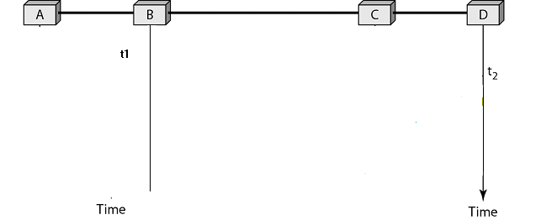
Figure No. 2
  - Complete the diagram (Fig. No. 2) considering B started transmitting at time t1=0, and D at time t2=2μsec. The distance between B and D is 2400m and the propagation speed is 2 x10⁸ m/s. When does the collision occur and what are the transmission times of B and D? [6 marks]

Question No. 5

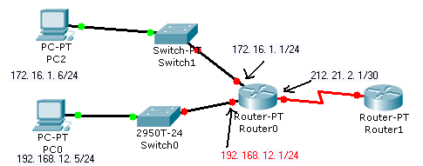
Figure No. 3

- Refer to the Figure No.3; PC0 is trying to send a packet to 200.20.20.2/24. What should be the default gateway of the workstation PC0? If the default gateway is configured incorrectly on the host, what is the impact on communications? Which portion of the network layer address does Router0 use to forward the packet to 200.20.20.2/24? If no route to the destination network is found, what will Router0 do? [5 marks]
- Explain what the following two commands will show. [3 marks]
  - ipconfig /all
  - netstat –r

- Why do VoIP applications uses UDP not TCP? Explain. [3 marks]

- What is the difference between Well Known port numbers and Registered port numbers? Give examples. [4 marks]

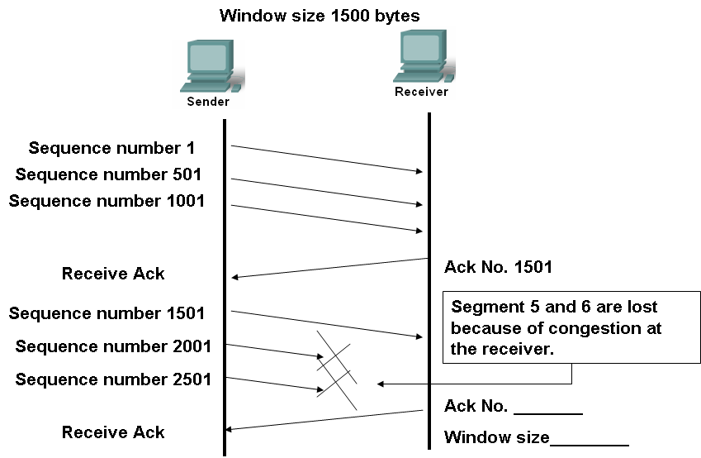
Figure No. 4

- Complete the diagram (Fig. No. 4) above and state what the sender will do next. [3 marks]

Question No. 6

- Using a 4 bit sequence number, what is the maximum size of send and receive windows for each of the following protocol: [4 marks]
  - Go-Back-N ARQ
  - Selective Repeat ARQ

- What is piggy backing? In which scenarios will piggybacking will improve efficiency? [3 marks]
- In order to economize the overhead of using HDLC protocol, it is suggested that the usage of Supervisory frames should be stopped. If we do so in which scenario, will this cause a problem? Also state why supervisory frames are used. [4 marks]
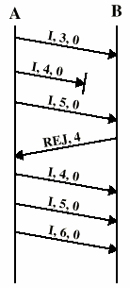

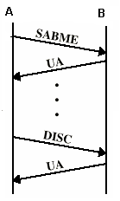

Figure No. 6

Figure No. 5

- Explain briefly what is happening in the diagrams (Fig No. 5 and 6) above, if the REJ, 4 was changed to SREJ, what changes would you see from the sender A. [7 marks]

Question No. 7

- Refer to the diagram below (Fig. No. 7); choose B1 as the root bridge/switch. Show the forwarding and blocking ports, after applying the spanning tree procedure. What does spanning tree protocol prevent? [6 marks]
B1
LAN1
B2
B4
B3
LAN3
LAN2
Figure No. 7

- Refer to the diagram below (Fig. No. 8); is there any difference when Host A sends a frame to Host C and when Host A sends a frame to Host D? Why or why not? [4 marks]

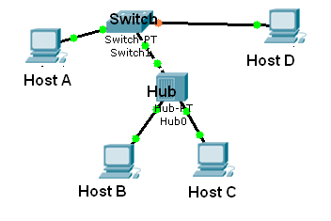
Figure No. 8

- A switch uses a filtering table, a router uses a routing table; can you explain the difference? [4 marks]
- How does a VLAN save company time and money? [4 marks]

THE END

